Uncovering the Earth’s skin
Patrick Jung
Laura Briegel-Williams
Lauren Nelson
Ernesto Llamas
Burkhard Buedel

Intimate Association
Where climatic conditions are harsh or disturbances reduce common plant coverage, biological soil crusts (BSCs) are established. These BSCs are groups of photosynthetic organisms like algae, mosses and lichens, that live within and on top of soil surfaces and co-occur with bacteria and fungi. As a skin, BSCs cover up to 12% of the Earth’s land surface from deserts to polar environments (Rodriguez-Caballero et al. 2018). With their root- and rope-like structures, and by the excretion of sugar-containing glue-like substances, BSCs bind soil particles and stabilise surfaces against erosion. BSCs are therefore considered to be ecosystem engineers (Figure 1).
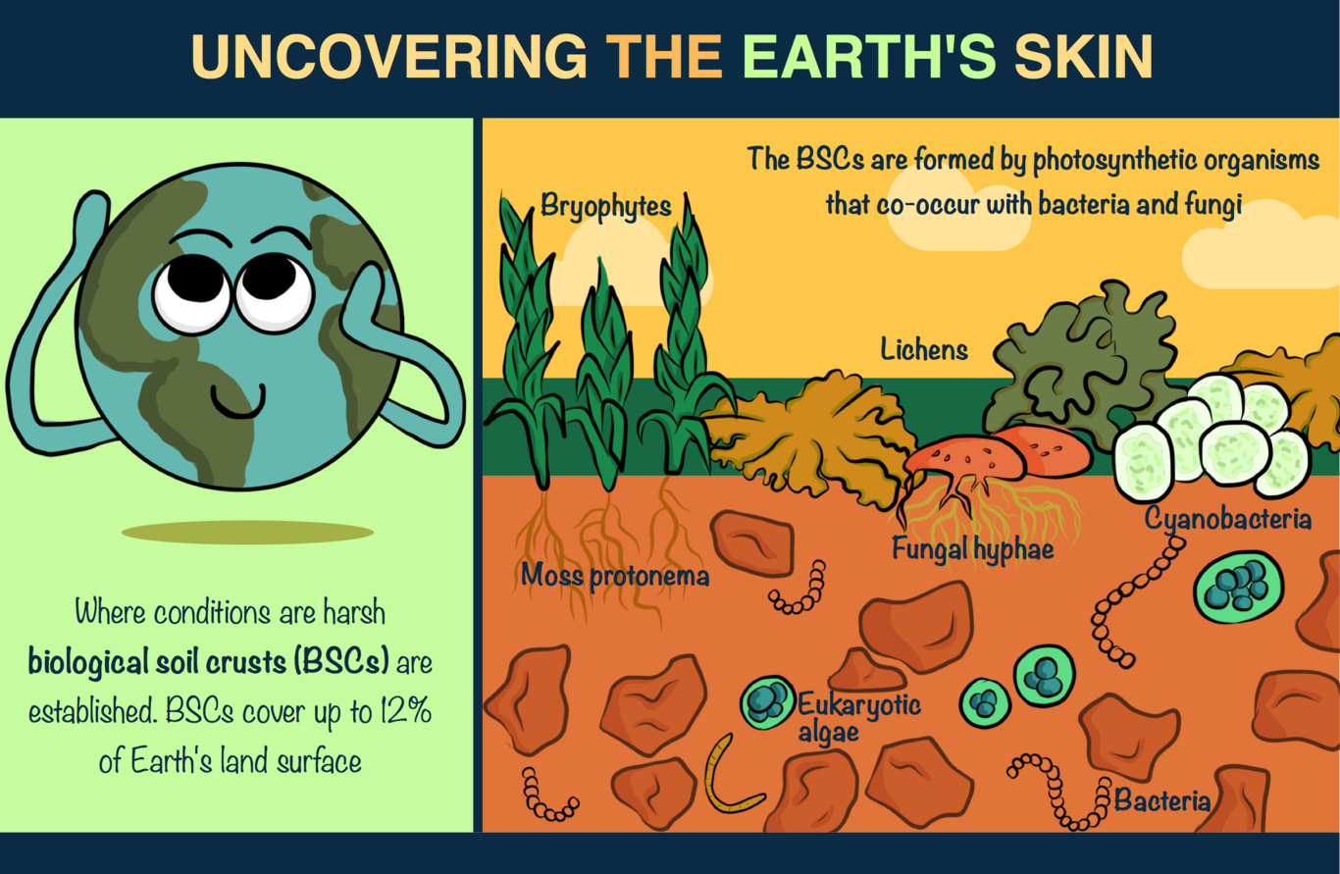
BSC Assemblage

Breathtaking
As a shared feature, BSC organisms lack the ability to maintain or regulate their water content. This inability makes these organisms highly dependent on water that is available in their surroundings. Unlike higher plants, lichens, green algae, mosses and cyanobacteria can survive long periods in a dessicated or completely dried out state (i.e. they can live in areas prone to drought or in freezing temperatures). These extremophile characteristics allow cyanobacteria and green algae communities to be the conquering pioneers of barren or disturbed areas (Belnap and Büdel 2016). This initial wave may be followed by the encroachment of mosses and lichens, especially where enough water is present. BSCs contribute to the development of an ecosystem as BSCs prime soils for plants through fertilisation. Cyanobacteria are especially important because they can bind to atmospheric nitrogen (N), which is often a limiting nutrient for plant growth. BSC organisms also fix carbon (C) during photosynthesis, taking the element from atmospheric CO₂. In turn, this helps reduce greenhouse gases and climate change. With these traits, BSCs are responsible for the fixation of up to 7% of carbon in comparison to net primary production by land plants, whilst they also account for ~50% of the biological nitrogen fixation on land (Elbert et al. 2012).
Our study was conducted in cold ecosystems (i.e. at the poles and in alpine environments) and published in the journal Biogeoscience (Jung et al. 2018). We showed that these soils, which are dominated by BSCs, are CO₂ sinks. This means that carbon fixed by BSC organisms is stored in the permanently frozen soils where, due to low temperatures, almost no breakdown of organic matter can occur. Therefore, growth and establishment of BSCs in these cold ecosystems means CO₂ is fixed and stored in the soils rather than being released into the atmosphere (Figure 2).

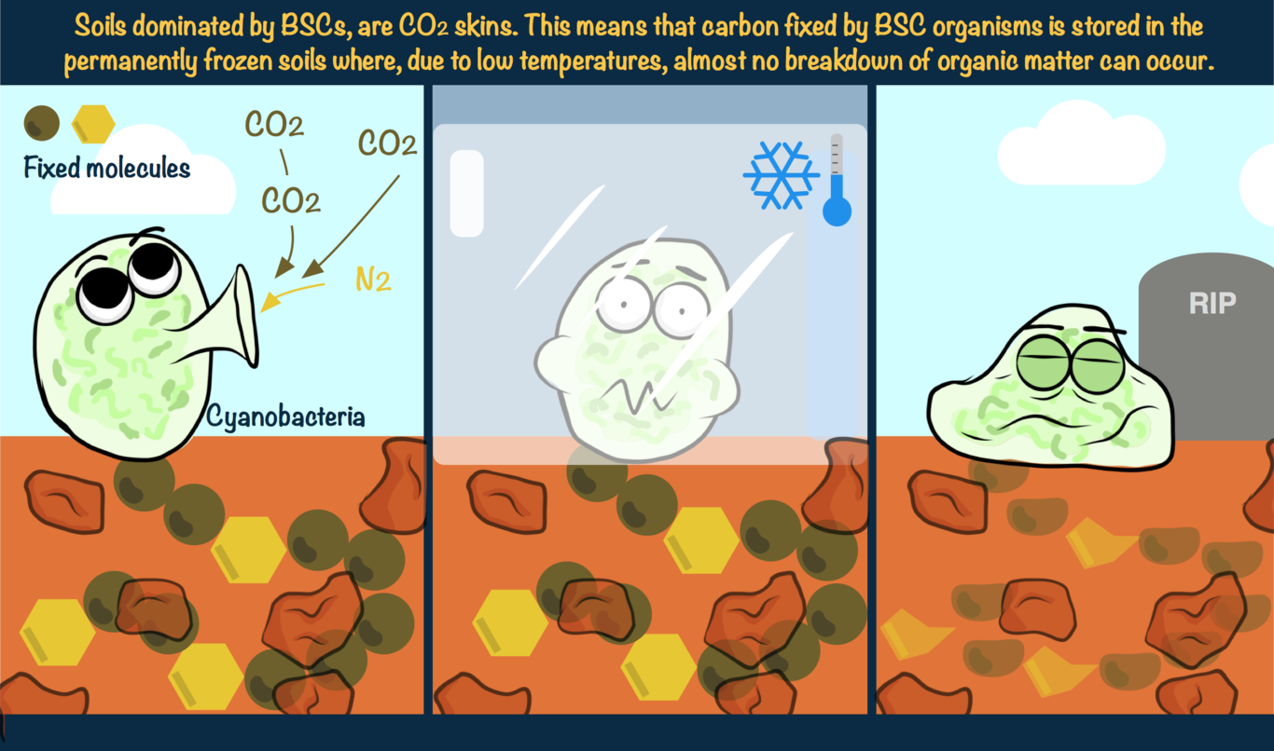
How cyanobacteria fix carbon dioxide and nitrogen and store it in soil
BSC research has been a hot topic in the past two decades however, the intimate interactions and arrangements between cyanobacteria, green algae, lichens and mosses within the soil itself has never before been visualised. To remedy this, we used a confocal laser scanning microscope (CLSM) which utilises laser light of specific wavelengths to visualise the active photosynthetic organisms like cyanobacteria. We viewed the BSCs from the soil surface, down to the deeper layers without destroying or disturbing the structure. When BSC organisms are dead, they can’t be visualised by CLSM. Despite this, the dead organic matter and glue excreted by the cells remains in the soil for a long time and are both important BSC features, aiding with continued soil stabilisation. After the microscopy stage, the information was processed with image analysis software. This software calculated the volume of carbon stored as biomass in the cyanobacteria and green algae at a specific soil depth. This analysis led to the creation of new terminology illustrated in Figure 3: a photosynthetic active layer (PAL) made of active organisms, and a photosynthetic inactive layer (PIL). The latter consists of the cell and glue remnants which stick to the soil particles and bind the BSC together. The thickness of the distinct layers is the result of complex interactions such as water availability, disturbance regime, soil texture and the developmental stage of a BSC. We created this technique at TU Kaiserslautern and could be applied to future studies, greatly enhancing comparisons of different BSCs.

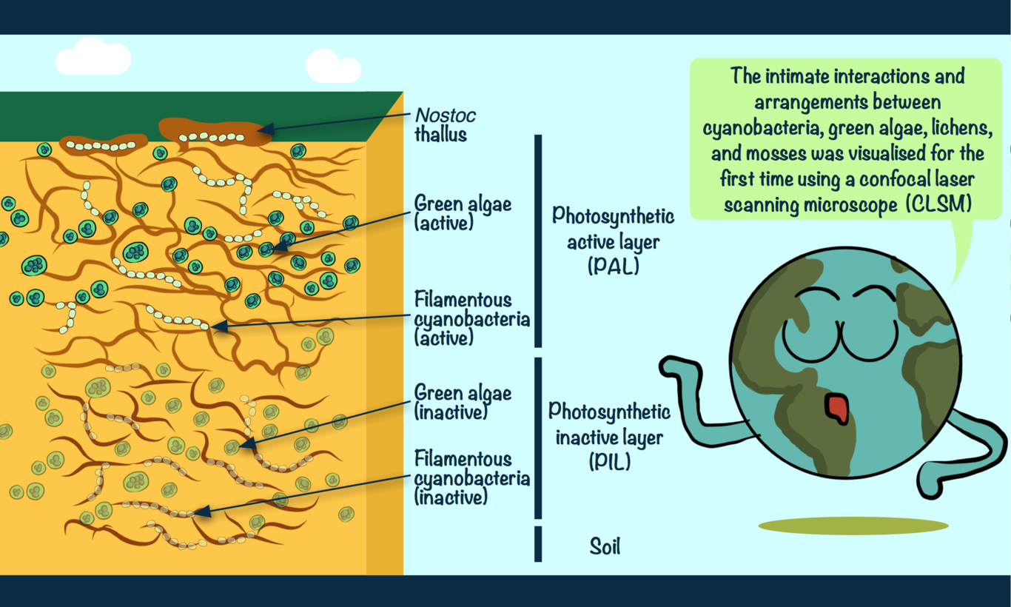
How a BSC cross section looks under CLSM

Contributions
-Patrick Jung is a Ph.D. student at TU Kaiserslautern (GER), working on lichens, cyanobacteria and green algae of the most extreme sites on Earth such as the poles or the Atacama Desert. He conducted the experiments and wrote the article. (Instagram @copperplants)
-Laura Briegel-Williams is a Post Doc at TU Kaiserslautern (GER), researching biological soil crusts of temperate and polar environments. She guided this work and edited the article.
-Burkhard Büdel is the head of the department of plant ecology & systematics at TU Kaiserslautern (GER). Throughout his career he has investigated biological soil crusts and summarized his work in a plethora of publications and books.
-Lauren Nelson edited the final article. Lauren is a Ph.D. student at Newcastle University (UK), researching computational drug design alongside the Northern Institute for Cancer Research. Lauren also writes a scientific blog aiming to stop science from seeming so boring. (Twitter @ashortscientist; Instagram @ashortscientist; Blog: ashortscientist.wordpress.com)
-Ernesto Llamas made the illustrations. He obtained his Ph.D. in Biotechnology from Universitat de Barcelona doing his research at Centre for Research in Agricultural Genomics. Creator of Sketching Science. Instagram @eellamas

References
Rodriguez-Caballero, Emilio, Jayne Belnap, Burkhard Büdel, Paul J. Crutzen, Meinrat O. Andreae, Ulrich Pöschl, and Bettina Weber. 2018. “Dryland Photoautotrophic Soil Surface Communities Endangered by Global Change”. Nature Geoscience 11 (3). Springer Nature: 185–89. doi:10.1038/s41561-018-0072-1.
Belnap, Jayne, and Burkhard Büdel. 2016. “Biological Soil Crusts as Soil Stabilizers”. In Biological Soil Crusts: An Organizing Principle in Drylands, 305–20. Springer International Publishing. doi:10.1007/978-3-319-30214-0_16.
Elbert, Wolfgang, Bettina Weber, Susannah Burrows, Jörg Steinkamp, Burkhard Büdel, Meinrat O. Andreae, and Ulrich Pöschl. 2012. “Contribution of Cryptogamic Covers to the Global Cycles of Carbon and Nitrogen”. Nature Geoscience 5 (7). Springer Nature: 459–62. doi:10.1038/ngeo1486.
Jung, Patrick, Laura Briegel-Williams, Anika Simon, Anne Thyssen, and Burkhard Büdel. 2018. “Uncovering Biological Soil Crusts: Carbon Content and Structure of Intact Arctic Antarctic and Alpine Biological Soil Crusts”. Biogeosciences 15 (4). Copernicus GmbH: 1149–60. doi:10.5194/bg-15-1149-2018.

