Supporting Information for “Fabrication of Soft and Wearable Electrostatic Generator Based on Streaming Electrification”
Shota Kamiyauchi
Yuki Yokoyama
Yu Kuwajima
Yumeta Seki
Satoshi Awaki
Shingo Maeda
Hiroki Shigemune

Figure S1
Experimental system: (A) overall view and (B) generator part.
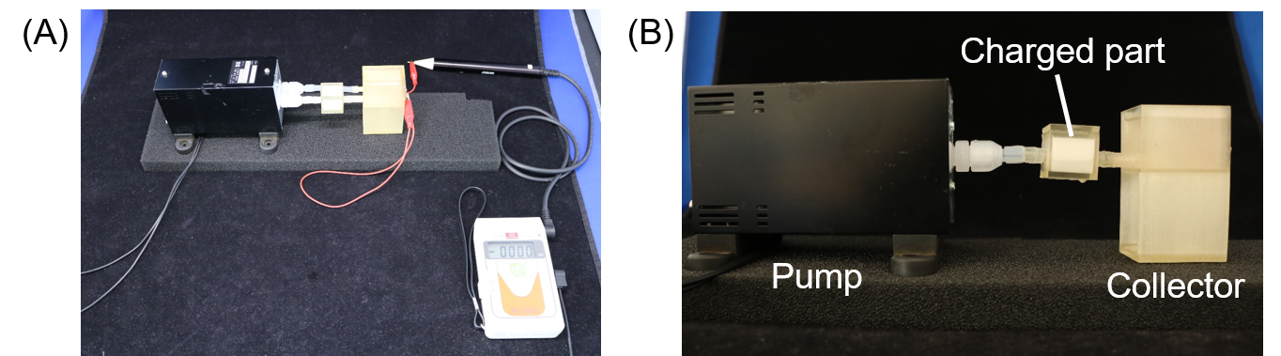

Figure S2
Photograph of charged part: (A) empty, (B) filled with melamine sponge, and (C) filled with urethane sponge.
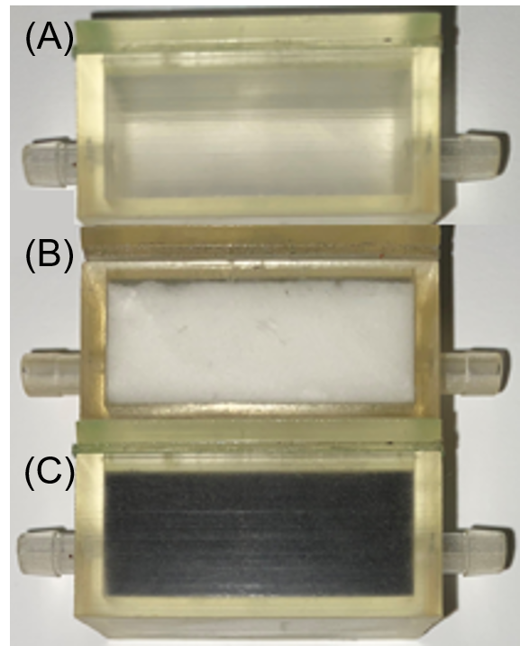

Figure S3
Design of sponge case: (A) lengths of 1, 2, and 4 cm, (B) 3D CAD model, and (C) 3D-printed parts.
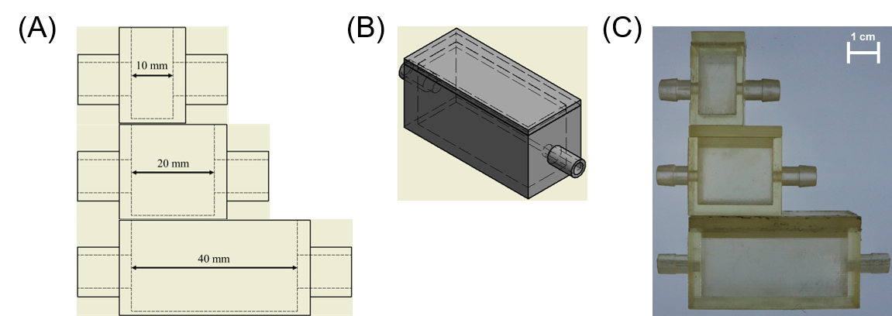

Table S1
Measurement conditions .
December 3, 2020, Shibaura Institute of Technology Laboratory, temperature: 2 F (21 ℃), RH: 40%

Figure S4
Relaxation of electric charge. When Novec 7300 flows into a melamine sponge, the melamine sponge becomes positively charged and Novec 7300 becomes negatively charged. When Novec 7300 flows into the positively charged melamine sponge, the opposite sign charges recombine with each other and the amount of charge decreases. We guess that relaxation of charge due to recombination to be the reason for the decrease in charge generation when the contact time is long.
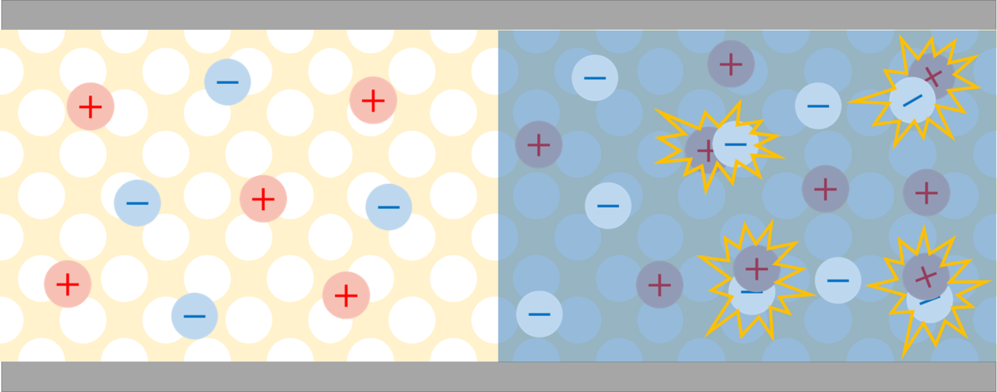

Figure S5
Durability experiment on the SEG. The SEG was directly connected to the digital multimeter to measure current and driven for 1800 seconds. The output current did not change much before the liquid volatilized.
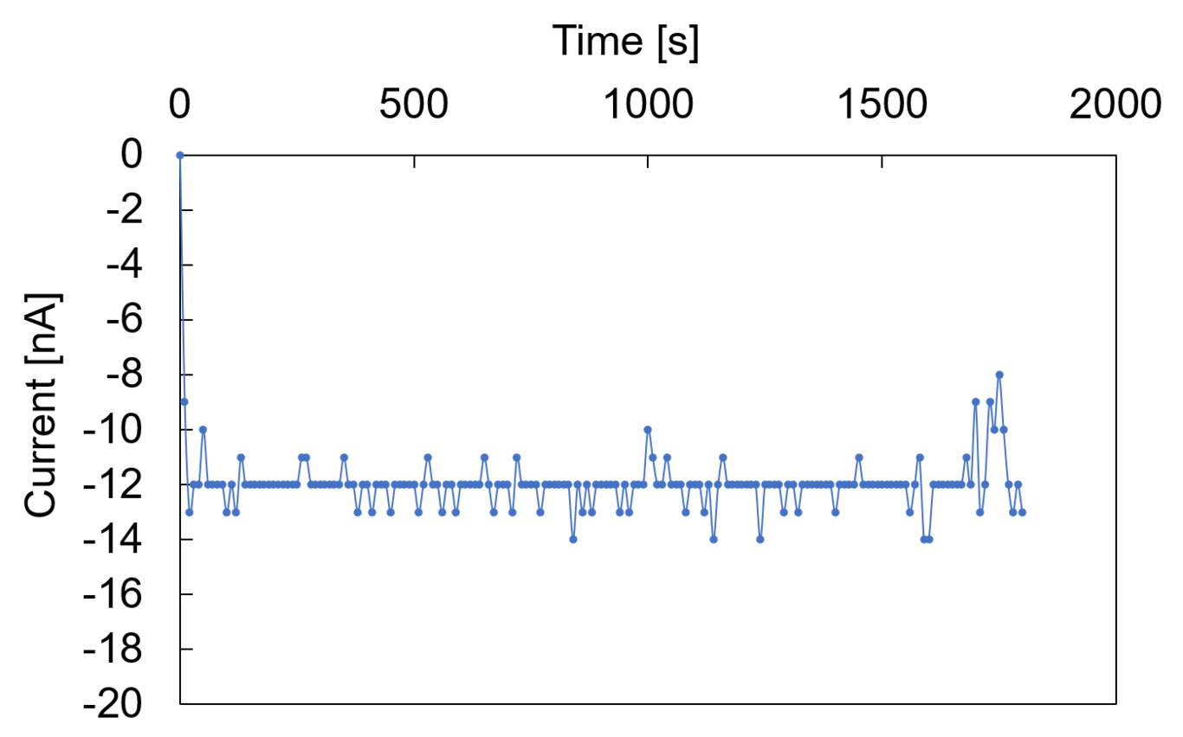

Equation S1
From Gauss’s law, we get
$$\int_{S}{E}⋅dS=\frac{Q}{ε} .$$
From Coulomb’s law, we get
$F=\frac{1}{4πϵ}⋅\frac{Q_{1}Q_{2}}{|r_{1}−r_{2}|}⋅\frac{r_{1}−r_{2}}{|r_{1}−r_{2}|^{2}}.$
From the model in Figure 3F, we get
$\begin{matrix}\overset{⃗}{OA} & amp;=(−asinθ,acosθ) \\ \overset{⃗}{OB} & amp;=(bsinθ,bcosθ).\end{matrix}$
where the force experienced by the charge at position A from that at position B is
$F_{AB}=\frac{1}{4πε}⋅\frac{Q_{1}Q_{2}}{|\overset{⃗}{OA}−\overset{⃗}{OB}|}⋅\frac{\overset{⃗}{OA}−\overset{⃗}{OB}}{|\overset{⃗}{OA}−\overset{⃗}{OB}|^{2}}.$
In addition, it is essential to note that the moment resulting from F_{AB} around O is
$\overset{⃗}{ΔN}=\overset{⃗}{OA}×\overset{⃗}{F_{AB}}.$
By setting the total moment around O=0, we get
$\overset{⃗}{N}=\sum_{a}{\sum_{b}{\overset{⃗}{OA}}}×\overset{⃗}{F_{AB}}=mg⋅\frac{h}{2}⋅sinθ.$
On substituting this in Equation 4, we get , we get
$\begin{matrix}\sum_{a}{\sum_{b}{\overset{⃗}{OA}}}×\frac{\overset{⃗}{OA}−\overset{⃗}{OB}}{|\overset{⃗}{OA}−\overset{⃗}{OB}|^{3}}⋅\frac{ρΔr⋅ρΔr}{4πε}=mg⋅\frac{h}{2}⋅sinθ.\end{matrix}$
Therefore, the relationship between the angle of the electroscope leaves and the charge density is as follows:
$ρ=\sqrt{\frac{sinθ}{\sum_{a}{\sum_{b}{\overset{⃗}{OA}}}×\frac{\overset{⃗}{OA}−\overset{⃗}{OB}}{|\overset{⃗}{OA}−\overset{⃗}{OB}|^{3}}}⋅\frac{mgh}{2}⋅\frac{4πε}{Δr^{2}}}$
where, ε is the permittivity of air, g is the acceleration due to gravity, m is the leaf mass, h is the leaf length, and O is the leaf junction point.

Figure S6
(A) Photograph of fluorescent lamp lit using SEG: (i) before being driven by SEG and (ii) after being driven by SEG. (B) Inside the fluorescent lamp: Electrons supplied by SEG are emitted from the electrodes of the lamp. The mercury vapor reflects the electrons that produce ultraviolet light, which is emitted by the luminescent material coated on the inner surface of the glass.
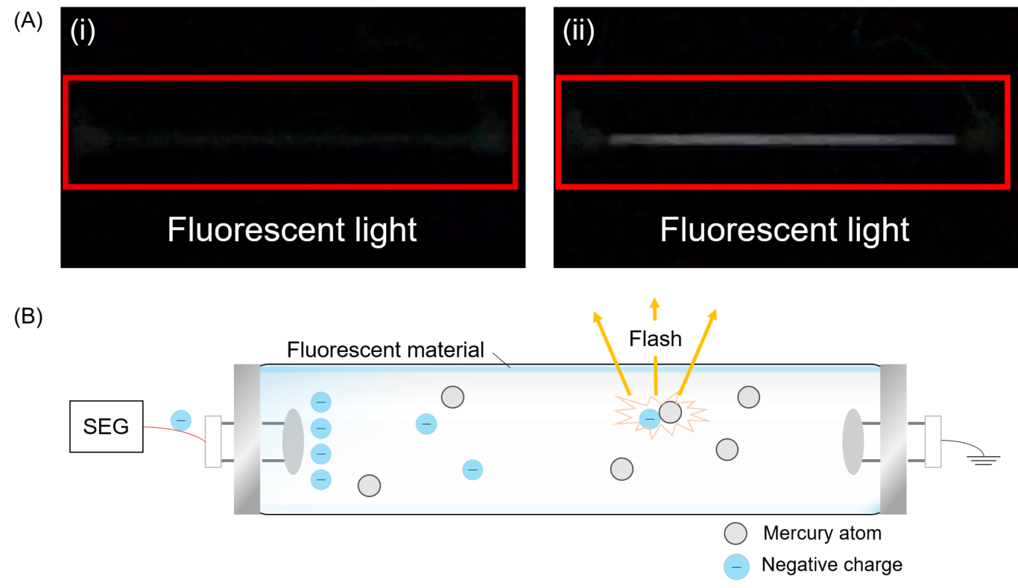

Figure S7
Amount of charge collected for each device (grasping, stamping, bending) fabricated using the SEG. “Start” is the point of the device activated. “Stop” is the point of the device deactivated. “Reset” is the point of the measurement system to be reset.
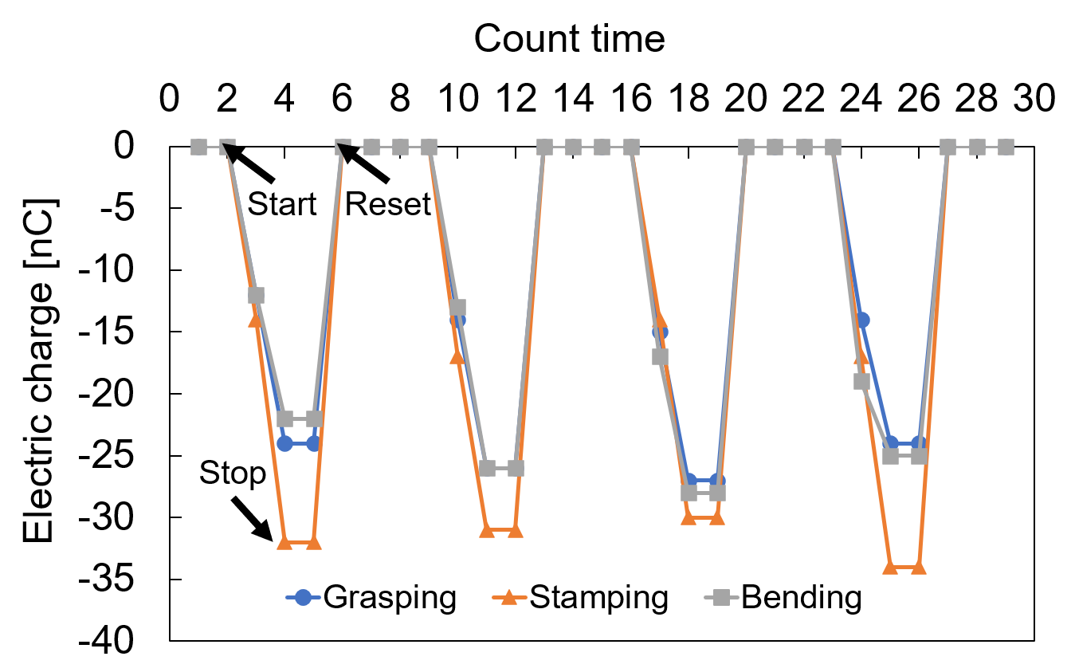

Supplementary Videos

Video S1
Rich media available at https://youtu.be/PS0l2riEGa0

Video S2
Rich media available at https://youtu.be/4eBQimxA1SU

Video S3
Rich media available at https://youtu.be/IbblsYSjFpY

Video S4
Rich media available at https://youtu.be/AG_vg6SeDUg

Video S5
Rich media available at https://youtu.be/sH1aWT8QWR8

Video S6
Rich media available at https://youtu.be/WX-fSDsUCJw

